**[Title Needed]**

These days, it’s fair to say the President Trump has been a prevalent topic of conversation. Turn on the news, pick up a newspaper, or scroll through Twitter and you will see the variety of ways people talk about Mr. Trump and his policies.

We wanted to take a closer look at the many ways people talk about the President of the United States. Naturally, we turned to the source with the richest data we could find: Twitter. Using tweet text, we trained a neural network that we could use to quantify how pro- and anti-Trump a piece of text sounds.

**Neural Net Overview**

We trained a neural network using tweets that have clear and strong pro-Trump or anti-Trump sentiment. We found these pro- and anti-Trump tweets using hashtags commonly used when expressing strong pro- or anti-Trump sentiment. To collect and label anti-Trump tweets, we used hashtags such as #NoRacistWall, #ImpeachTrump, and #LiarInChief. To collect and label pro-Trump tweets, we used hashtags such as #MAGA, #BuildThatWall, and #VoteTrump. This resulted in a large set of tweets from a variety of everyday Twitter users that we could label as 1, strongly pro-Trump, or 0, strongly anti-Trump.

The input to our neural net is the text of a tweet and the output is the tweet’s Trump polarity score. The outputted polarity score is the probability that a tweet sounds like an anti-Trump tweet. That is, if the score is closer to 1, the language in the tweet is more likely to sound similar to that of an anti-Trump tweet, and if it is closer to 0, it is more likely to sound like a pro-Trump tweet.

**Results**

We were interested in seeing the polarity scores from popular twitter accounts to see how similar they sound to typical pro-Trump or anit-Trump rhetoric.

To find an account's polarity score, we took the average polarity score of a large number of their tweets. It is important to note that we do not treat these account scores as absolute measures of how pro- or anti-trump a user is, but as a relative measure for how much their tweets sound like the tweets of other pro- or anti-Trump users.

We looked at a selection of users from a few different categories, such as cable news networks, prime time cable news hosts, newspapers, and journalists. The results are shown and discussed below.

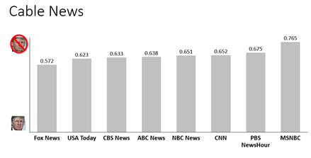

The cable news network results above follow the pattern we expected. Fox News has the lowest score and MSNBC has the highest, meaning Fox News’s tweets, on average, sound more similar to pro-Trump user tweets than MSNBC’s tweets do. The average score of tweets from all cable news networks is 0.651. Does this mean all cable news networks lean anti-Trump? No, not necessarily. These scores are relative measures of polarity. Additionally, these cable news scores are higher than you may expect, possibly because of the nature of news headlines.

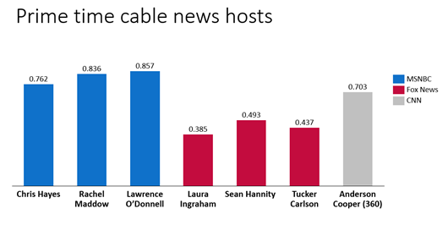

We took a closer look at some prime time cable news hosts. Above we see the personal twitter accounts of MSNBC hosts Chris Hayes, Rachel Maddow and Lawrence O’Donnell have even higher scores than the MSNBC twitter account. Similarly, the personal twitter accounts of Fox News hosts Laura Ingraham, Sean Hannity, and Tucker Carlson have even lower scores than the Fox News account.

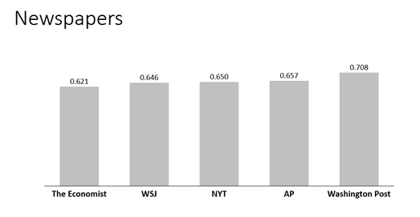

Newspaper Twitter accounts above are in the same range as the cable news accounts.

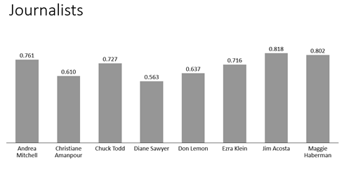

Finally, we looked at the Twitter accounts of well known journalists, and the results are above. Unsurprisingly, Jim Acosta, a journalist known to be not a very big fan of Mr. Trump, has the highest score.

In addition to these averages, we also saw interesting patterns in the standard deviation of account polarity scores. Breitbart News had the lowest standard deviation among the accounts we tested. With an average polarity score of 0.426, Breitbart’s twitter account had a standard deviation of 0.243, indicating that its tweets more consistently sound similar to that of pro-Trump users. Other users with low standard deviations include Rachel Maddow (0.294) and Lawrence O’Donnell (0.290). In contrast, Laura Ingraham had the highest standard deviation of 0.421. Other accounts with high standard deviation include Tucker Carlson (0.413), Fox News (0.418), ABC News (0.410), and the Associate Press (0.410). This high variance may be due to more variable sentiment, possibly to appeal to a wider audience. It also could be due to the use of headlines and quotes from other sources used to demonstrate disagreement, for example.

Finally, because we know everyone is wondering, Kanye West had an average polarity score of 0.505 #FREEASAPROCKY